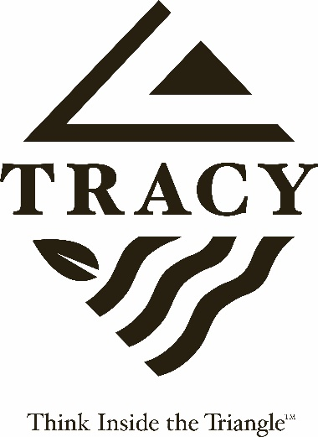

NOTICE OF CANCELLATION

TRANSPORTATION ADVISORY COMMISSION
THURSDAY, MARCH 9, 2023
7:00 P.M.

The regularly scheduled Transportation Advisory Commission meeting of Thursday, March 9, 2023 has been canceled due to lack of quorom.

The next regularly scheduled Transportation Advisory Commission meeting will be held on Thursday, April 13, 2023, at 7:00 p.m., Tracy Transit Station, Room 103, 50 E. 6th Street, Tracy.

Posted: March 9, 2023

